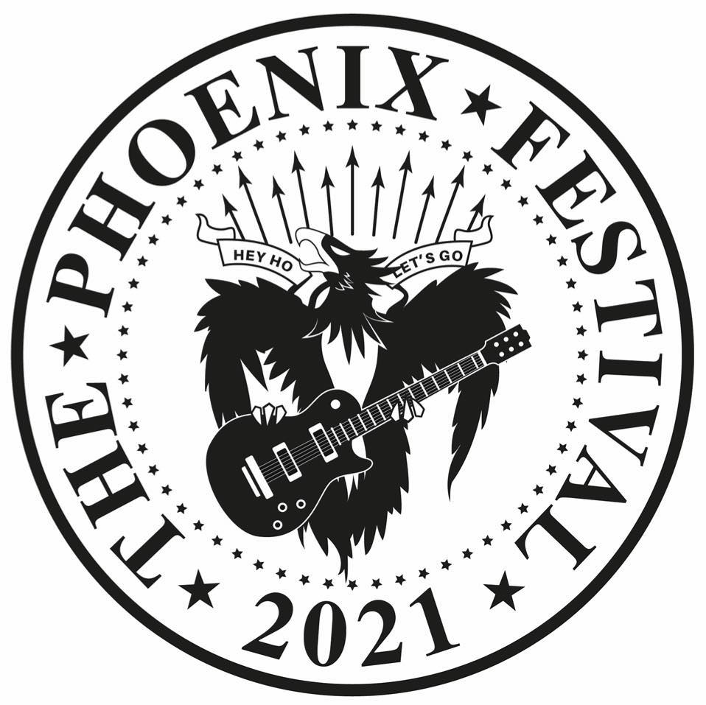

MEDIA RELEASE
29th March 2021
For immediate release

The Phoenix Festival Launches Fundraising Campaign
The Phoenix Festival organisers are asking everyone who has attended and has yet to attend this two-day free-to-enter community event to make a donation to its Just Giving page and help the Phoenix soar again this summer!
Glen Moreman Festival Manager said: “We’re acutely aware, we are all in difficult times and organisers of any event are undoubtedly under some strain. We are however, still tentatively planning to go ahead this summer but because 2020 was cancelled, due to Covid-19, we have lost a huge chunk of our funding and are now in a critical position.”

The Festival costs around £50,000 to stage all of which is raised by a small volunteer committee through grants, sponsorship, concessions and donations. Some financial and in-kind support is provided by the Cirencester Community Development Trust, Cirencester Town Council and Cotswold District Council and some local businesses too but this year there is a £15,000 shortfall.

Glen Moreman adds “Since the 2019 festival we have not been able to complete any fundraising, as there have been far more important things going on in the world. So we now find ourselves faced with a shortfall of approximately £15,000 that we need to raise. If everyone who likes our social media pages and who’s been to the festival donated just £2 each then we would achieve our goal easily, we know times are tough, but this is the reality.”

To help you can:

Donate via the Phoenix Festival Just Giving page www.justgiving.com/fundraising/phoenixfestival2021

Like and Share the Phoenix Festival Facebook page

www.facebook.com/Phoenix.Festival.Ciren

Contact the Phoenix Festival by email: info@phoenix-festival.co.uk

Images 1-3:
- Phoenix Festival 2019 photo credit: Martin Reynolds
- Phoenix Festival 2019 photo credit: Martin Reynolds
- Phoenix Festival 2019 photo credit: LPA Photography
Contact Details
- Email info@phoenix-festival.co.uk
- Website www.phoenix-festival.co.uk
- Twitter: @Phoenixfest2020
- Instagram: phoenixfest20
- Hashtag: #phoenixfest20
For press use only and not for publication
Glen Moreman (Festival Manager) Lucy Cordrey (Festival Media contact)
Mob: 07739 209124 Mob: 07716 826467
glen@phoenix-festival.co.uk lucycordrey@talktalk.net

Notes to Editors:
- The Festival Committee have set themselves a target of 1st May 2021 as a decision point. If things look positive then they may extend this further or they may have to postpone until 2022.

- The Phoenix Festival is organised entirely by a volunteer team who do so out of their own enthusiasm for the event and the community and at no financial gain to themselves. All the artists and performers (apart from the special guests) also give their time freely to make the weekend an incredibly special event.

- Due to the timescales involved, the Festival will not be accepting any performance applications this year but instead the Festival will contact artist and performers.

More about the Phoenix Festival
- The Phoenix Festival is a totally free to enter, open to everyone, two-day local music and performing arts event.
- The Festival is organised through the registered charity and company Cirencester Community Development Trust and is supported by Cirencester Town Council who provide the Festival site, the Abbey Grounds, at no charge.
- The Festival is now in its eighth year and plans to take place on 28th & 29th August 2021.
- The Festival has hosted a number of the UK’s top tribute acts: the Ultimate Beatles (2015); Oas-is and Who’s Next (2016); David Live and Los Palmas 6 (2017); Arrival and Flash (2018); The Rolling Clones and Totally Tina (2019).
- The Festival brings the local community together, involves Cirencester’s young people and offers a unique platform to showcase local talent.
- Young people and volunteers of all ages make it happen.
- Over 100 volunteers help out over the two days and an additional 50 for the week during the festival and pre-festival site build.
- Sponsors, grants and donations keeps free entry.
- Over 15,000 people regularly attend the Phoenix Festival.
- The Festival was the brainchild of Ozone (a youth club for young people aged 13-19) and would not exist without the youth of Cirencester.
- The first Phoenix Festival in Cirencester was held in 2013.

